**CREATE AN IBM CLOUD ACCOUNT**

#### **Step 1:** Sign up

Please go to [IBM CLOUD](https://cloud.ibm.com/) and click “create a free account” as shown below.

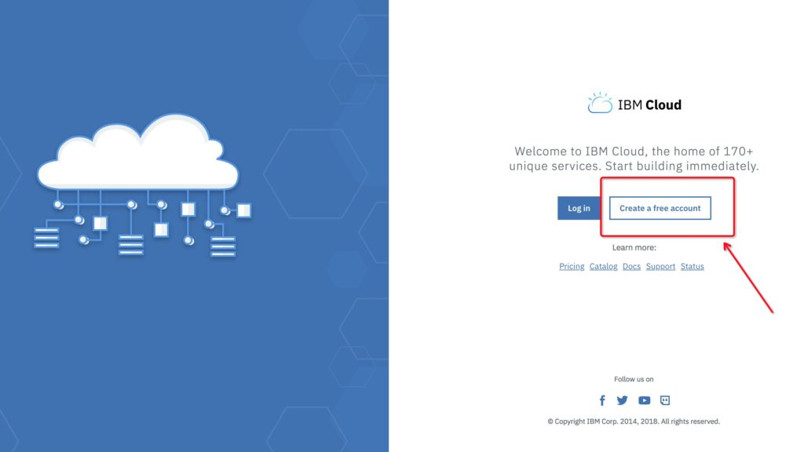

#### **Step 2:** Create Account

Click on Create in the bottom-left after filling in the form as shown in the figure below.

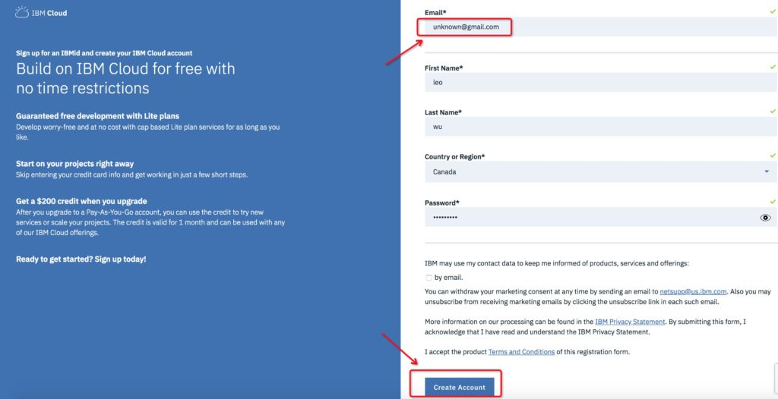

After registration completes, you will see the screen below.

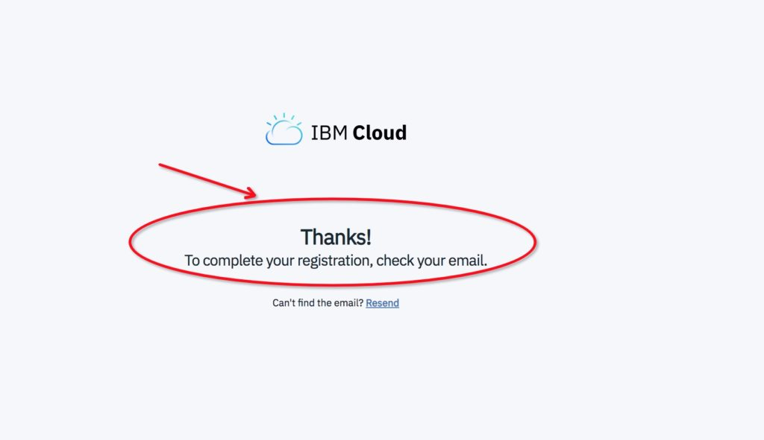

#### **Step 3: Complete registration**

At last, you must log in your email box and activate your account according to the guide from IBM Cloud by click “Confirm Account” button as shown below.

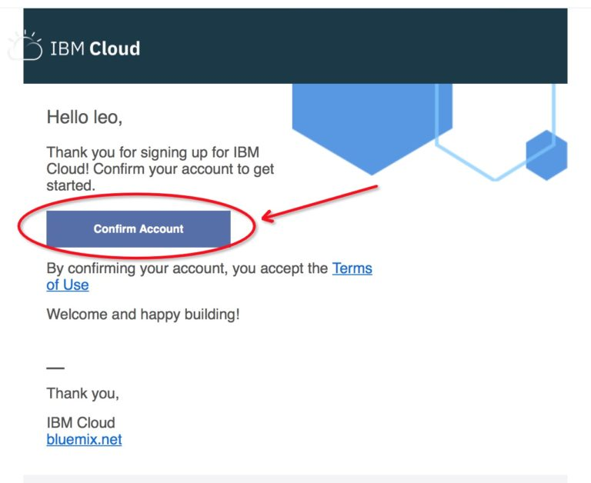

You can now log in [IBM CLOUD](https://cloud.ibm.com/)using your email and password!